Basic Parts of a Parachute:
How a parachute works: https://www.youtube.com/watch?v=vZYwsAvHgVw

https://www.youtube.com/watch?v=S6aJ9DSYOHk

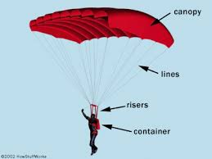

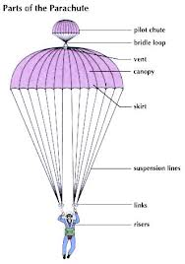

How Hot Air Balloons Work:

https://www.youtube.com/watch?v=77Ej_Ayugxk

